**Python Scenario Based Assignment**

Question: **Online Learning Platform**

Name: **Harish Er**

**Database:**

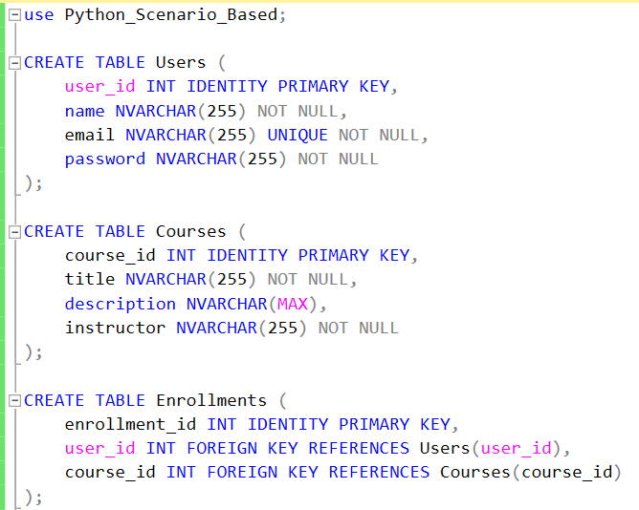

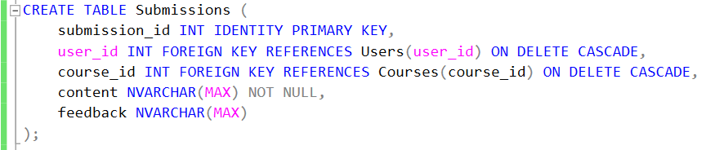

**Output:**

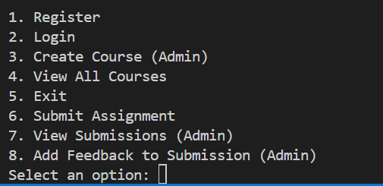

1. **Register User:**

**Before Register:**

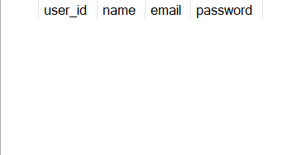

**After Register:**

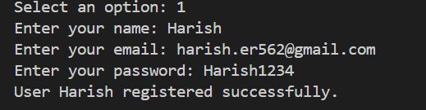



1. **Create Course:**

**Before Create Course:**

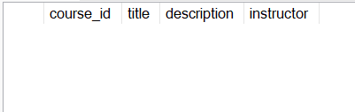

**After Create Course:**

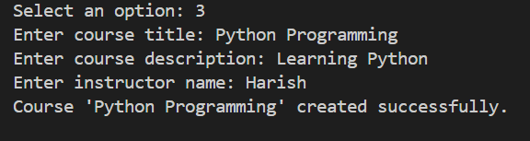

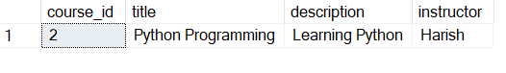

1. **Submit Assignment:**

**Before Submit Assignment:**

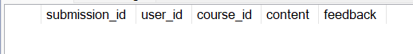

**After Submit Assignment:**

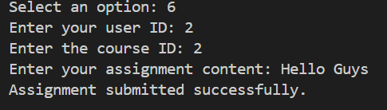

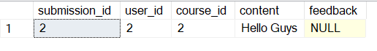

1. **Submit Feedback:**

**Before Submit Feedback:**



**After Submit Feedback:**

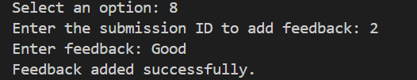

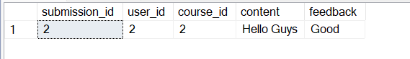

1. **Exit:**

